
Business Question and Visualization Report

Date | 27 October 2026
Team ID | Individual
Project Name | Global Olympic Sports Performance Analysis
Maximum Marks | 5 Marks

Visualization development refers to the process of creating graphical representations of data to facilitate understanding, analysis, and decision-making. The goal is to transform complex datasets into visual formats that are easy to interpret, enabling users to gain insights and make informed decisions. Visualization development involves selecting appropriate visual elements, designing layouts, and using interactive features to enhance the user experience. This process is commonly associated with data visualization tools and platforms, and it plays a crucial role in business intelligence, analytics, and reporting
Business Questions and Visualisation
The process involves defining specific business questions to guide the creation of meaningful and actionable visualizations in Tableau. Well-framed questions help in identifying key metrics, selecting relevant data, and building visualisation that provide insights.
Sample
1. What are the monthly sales trends?
  - Visualization: Line chart showing monthly sales trends.
  - Screenshot of visualisation
- Which products have the highest revenue?
  - Visualization: Bar chart comparing revenue by product
  - Screenshot of visualisation
- How is customer satisfaction varying across regions?
  - Visualization: Map visualization showing customer satisfaction by region.
  - Screenshot of visualisation

Note: Min 8 business question and visualisations Required inform of above

Business Questions and Visualisations
The following 9 business questions align with the proposed worksheets. Add final Tableau screenshots after building and validating the corresponding charts.
Sheet 01: Which countries have the highest recorded all-time medal totals?
Visualization: Horizontal bar — Global Medal Performance by Country. Data source: alltime_country_rankings.csv. Fields: country; total_medals. Stakeholder scenario: Priya. Evidence: Tableau screenshot of Sheet 01 below.
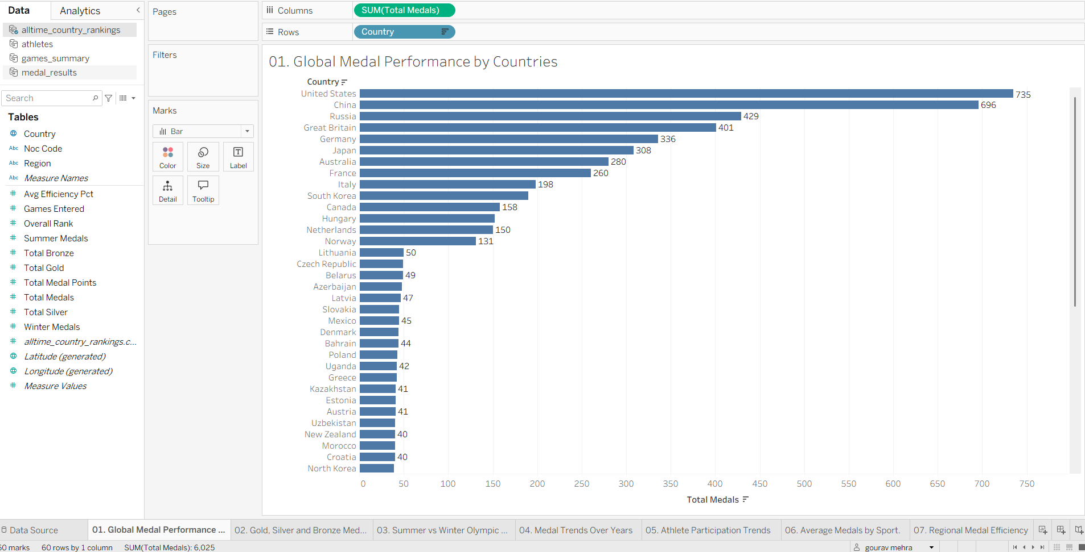
Sheet 02: How does each country's medal total split into gold, silver and bronze?
Visualization: Stacked horizontal bar — Gold, Silver and Bronze Medals by Country. Data source: alltime_country_rankings.csv. Fields: country; total_gold; total_silver; total_bronze. Stakeholder scenario: Priya. Evidence: Tableau screenshot of Sheet 02 below.
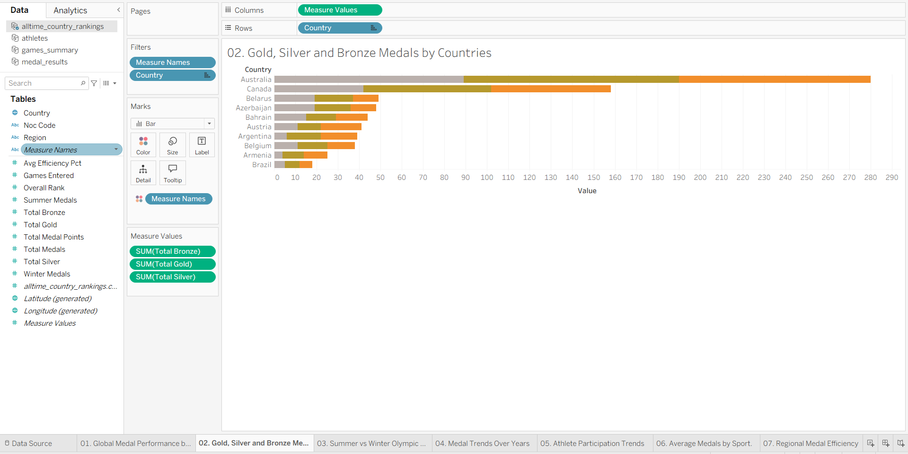
Sheet 03: How do recorded Summer and Winter medal totals compare by country?
Visualization: Side-by-side bars — Summer vs Winter Olympic Medal Comparison. Data source: alltime_country_rankings.csv. Fields: country; summer_medals; winter_medals. Stakeholder scenario: Priya. Evidence: Tableau screenshot of Sheet 03 below.
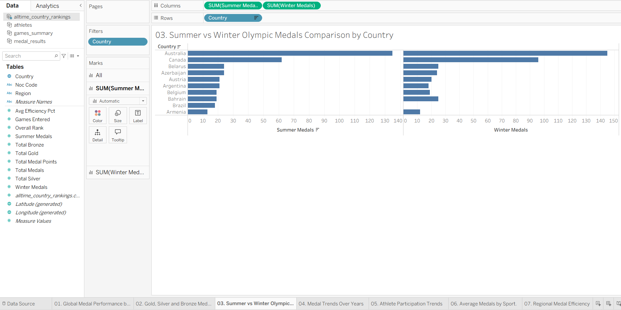
Sheet 04: How do recorded medal totals vary by Olympic year and season?
Visualization: Line — Total Medals Awarded Over the Years. Data source: games_summary.csv. Fields: year; total_medals_awarded; season. Stakeholder scenario: William Robert. Evidence: Tableau screenshot of Sheet 04 below.
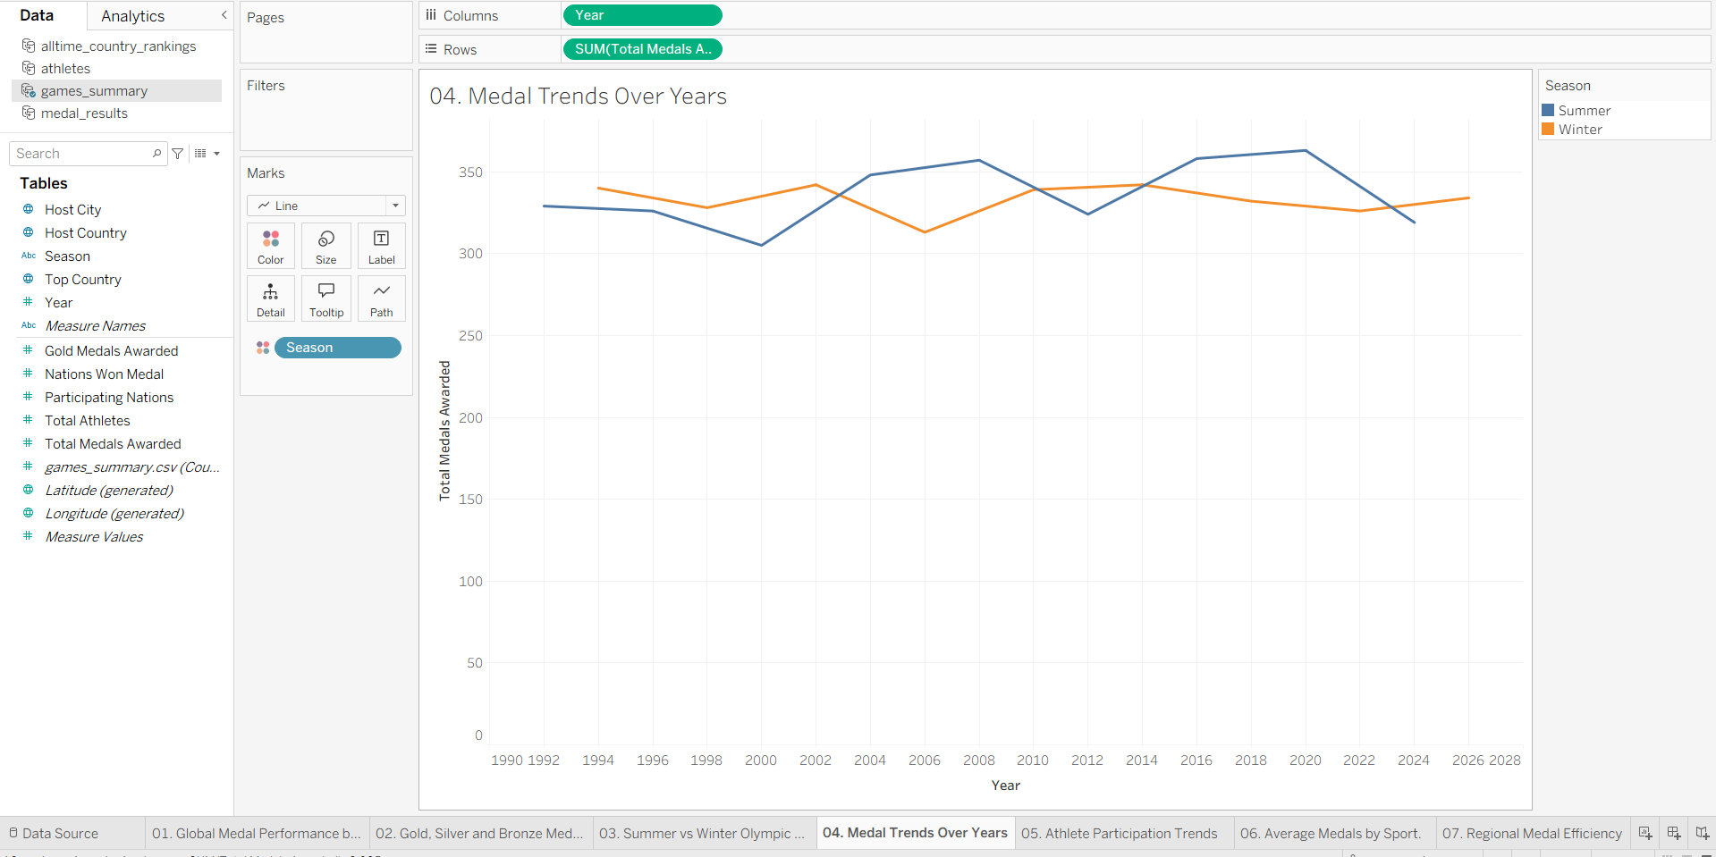
Sheet 05: How does recorded athlete participation vary across Olympic years and seasons?
Visualization: Line — Athlete Participation Trends Across Olympic Games. Data source: games_summary.csv. Fields: year; total_athletes; season. Stakeholder scenario: William Robert. Evidence: Tableau screenshot of Sheet 05 below.
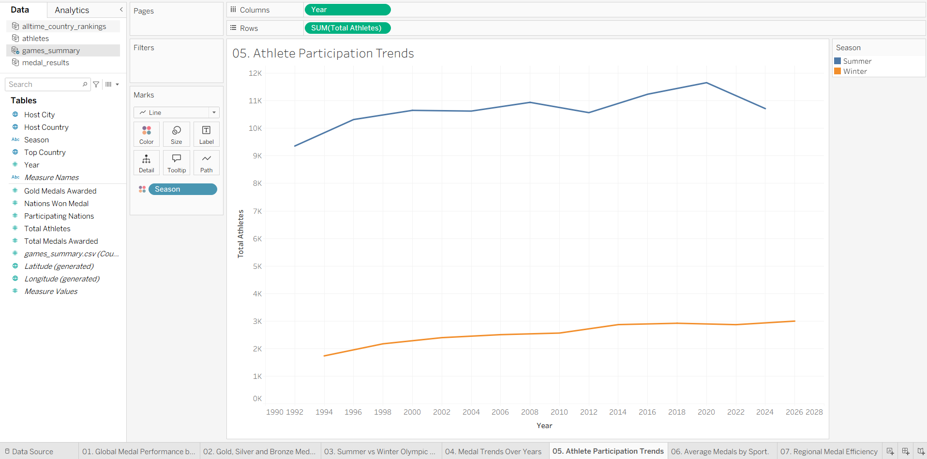
Sheet 06: Which sport categories have the highest average medals per athlete record?
Visualization: Horizontal bar — Average Medals per Athlete by Sport Category. Data source: athletes.csv. Fields: sport_category; AVG(total_medals). Stakeholder scenario: Priya. Evidence: Tableau screenshot of Sheet 06 below.
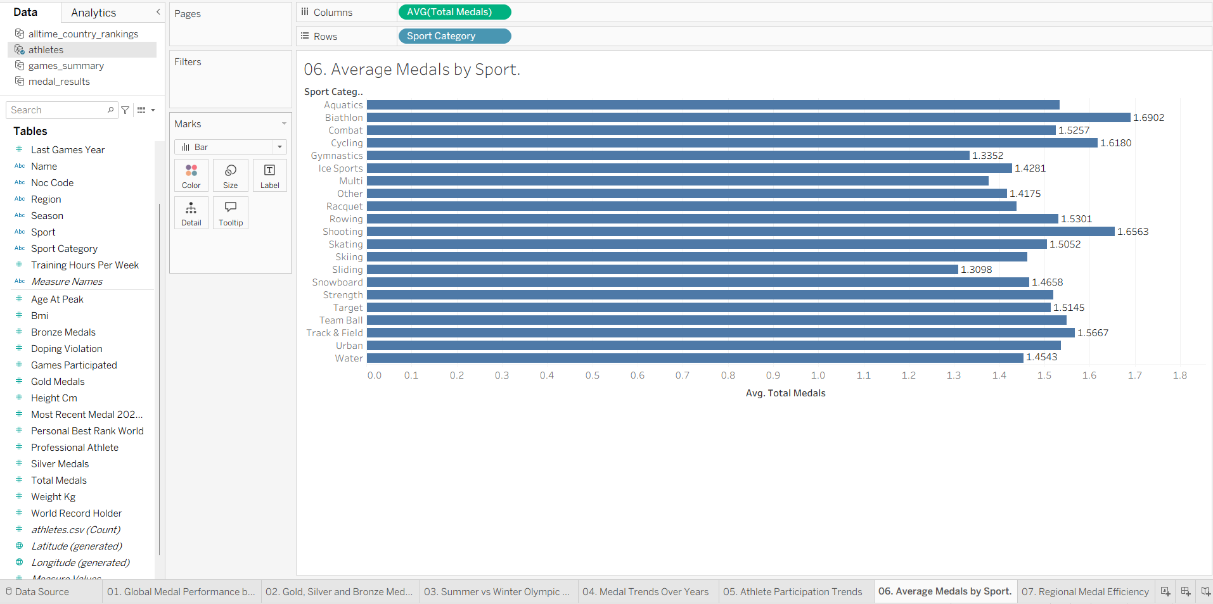
Sheet 07: How does the dataset's recorded average medal-efficiency metric vary by region?
Visualization: Bar — Average Medal Efficiency by Region. Data source: medal_results.csv. Fields: region; AVG(medal_efficiency_pct). Stakeholder scenario: Carlos. Evidence: Tableau screenshot of Sheet 07 below.
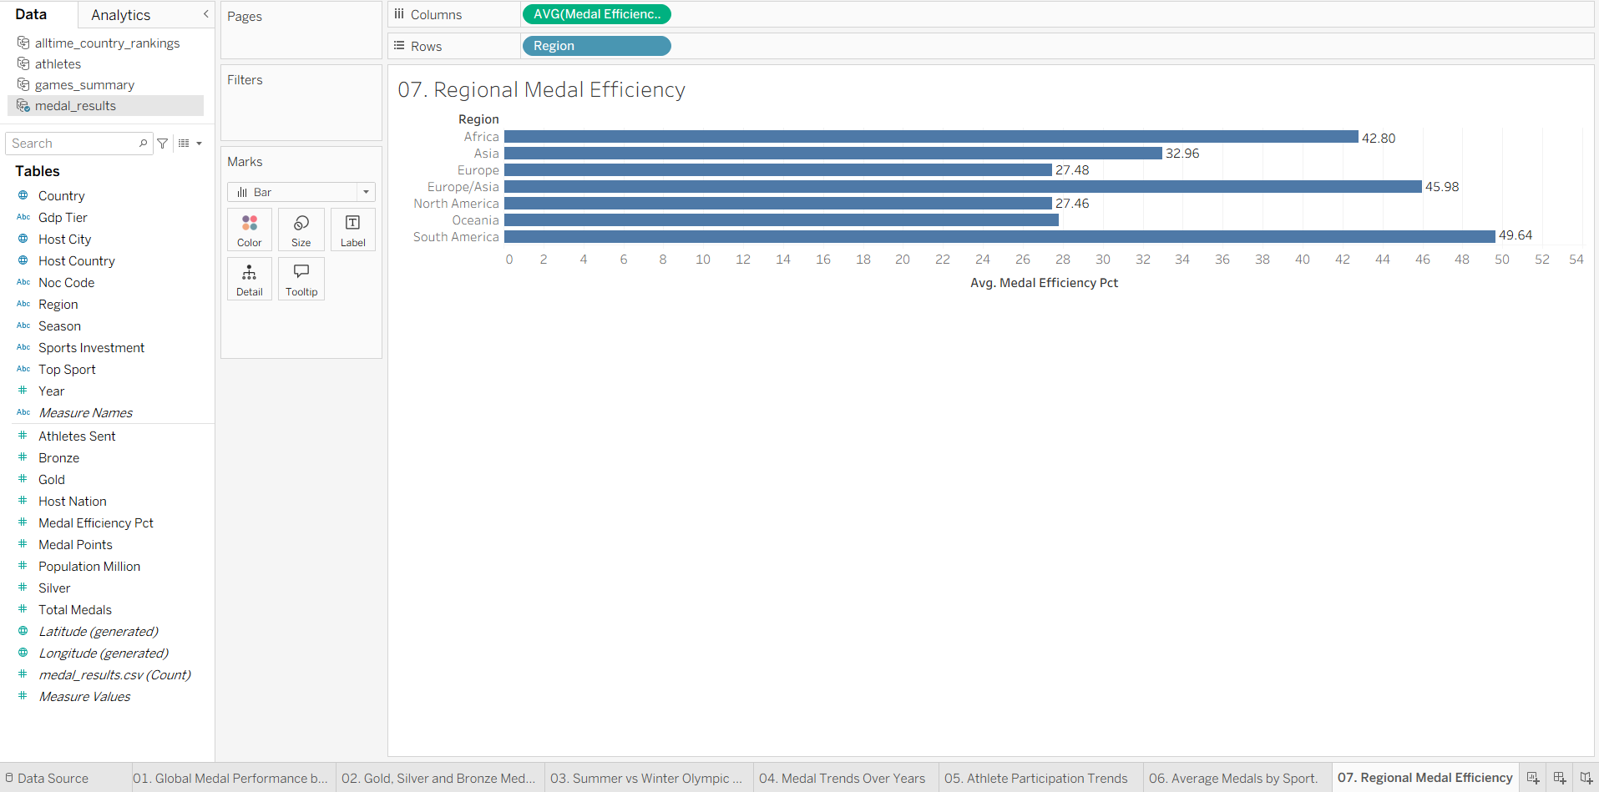
Sheet 08: How do recorded medal totals differ across High/Medium/Low investment tiers?
Visualization: Bar — Average Medal Performance by Sports Investment Tier. Data source: medal_results.csv. Fields: sports_investment; AVG(total_medals); region (optional color). Stakeholder scenario: Carlos. Evidence: Tableau screenshot of Sheet 08 below.
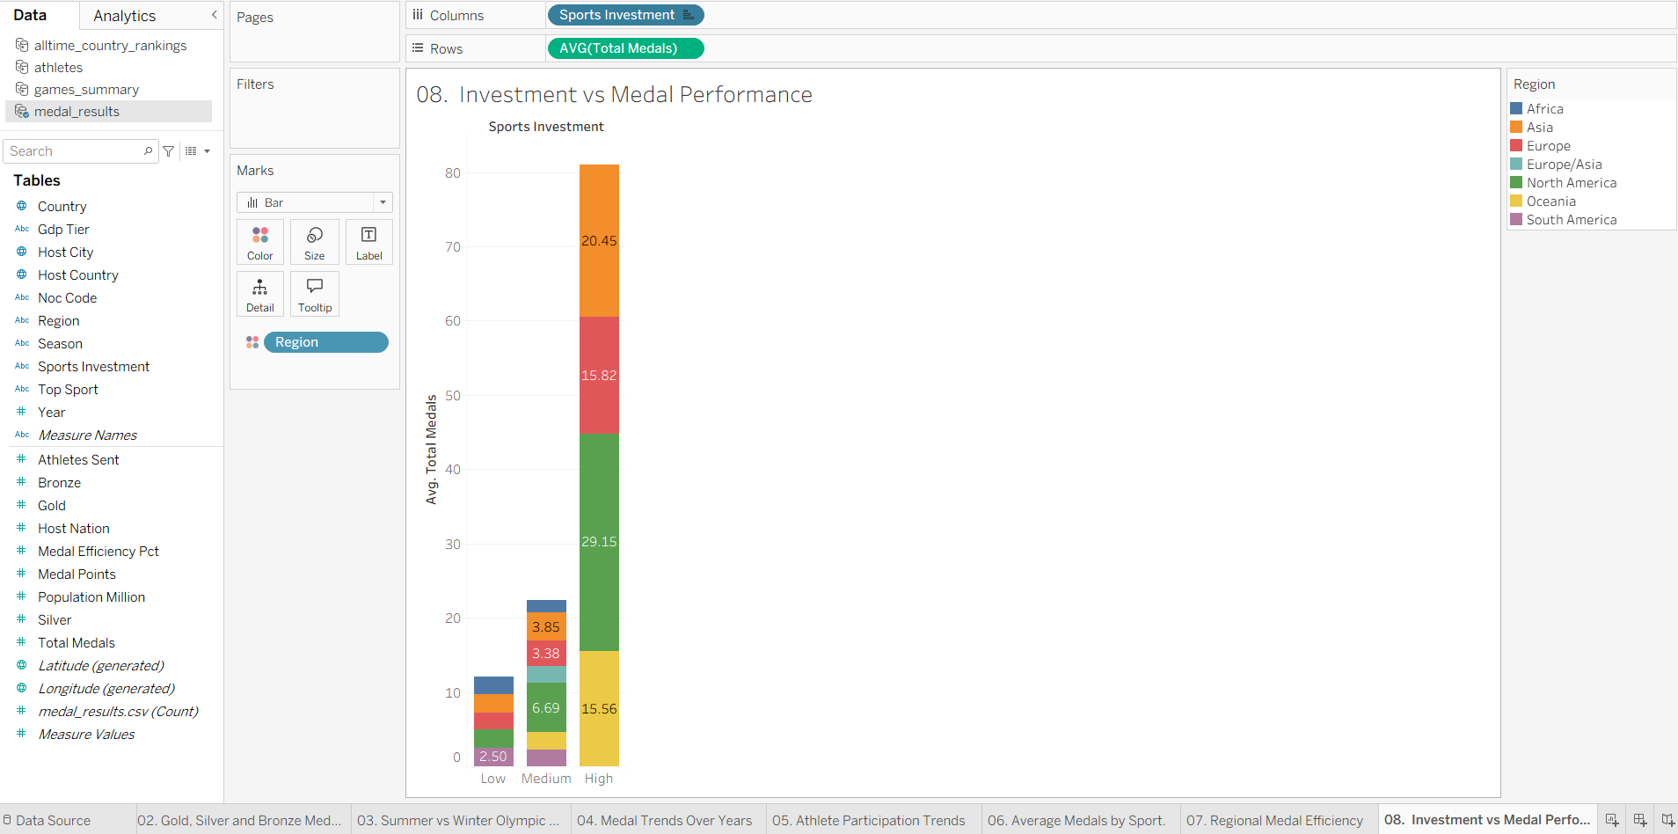
Sheet 09: How many medals did the host nation record at each Games?
Visualization: Bar — Host-Nation Medal Performance Across Games. Data source: medal_results.csv. Fields: year; host_country; country; total_medals; host_nation. Stakeholder scenario: William Robert. Evidence: Tableau screenshot of Sheet 09 below.
